
Summer Training Project On
‘Automatic File Rename and Organizer Using Python’
Submitted by
K.BHARANI SRINIVASA MURTHY
Registration Number: 12306569

Submitted to: Mr. Gaurav Sharma

In partial fulfillment of the requirements of the
award of the degree of B.Tech (Computer Science &
Engineering)

School of Engineering
Lovely Professional University, Phagwara, Punjab.
Introduction
Managing large numbers of digital files is a common challenge in personal and professional environments. Manual renaming and organizing of files can be time-consuming and error-prone. This project develops a Python-based Automatic File Renamer and Organizer to automate these processes. The application scans a directory, displays all files, allows the user to rename selected files, and organizes them into folders by file extension. By automating routine file management tasks, this tool improves efficiency and reduces human error.
Problem Statement
In many cases, users accumulate hundreds of files over time without a consistent naming or organization strategy. This leads to:
- Time Consumption: Sorting and renaming files manually requires significant effort.
- Human Error: Files may be misnamed or misplaced, making them difficult to find later.
- Lack of Consistency: Inconsistent folder structures can lead to confusion and data loss.
To address these challenges, this project proposes a solution that automatically manages files using a simple Python script.

Objective
The main objective of this project is to develop a Python application to automate file renaming and organizing. The core features of the application include:
- Display Files: List all files present in the specified directory.
- Rename Files: Allow users to rename files as needed.
- Organize by Extension: Move files into categorized folders based on their file type (e.g., PDF, DOCX, TXT).
- Rescan Directory: Refresh the file list after changes.
- Menu-Driven Interface: Provide an easy-to-use console menu for navigation.

Technology & Tools Used
Programming Language:
- Python: A versatile language that supports rapid development of file-handling scripts
Concepts Used:
- • Functions: Logic is separated into reusable functions for clarity.
- • Namedtuple: Lightweight data structures to hold file information (name, extension, path).
- • Lists: To store collections of files.
- • OS and Shutil Modules: For interacting with the file system.
- • Loops & Conditionals: For handling user input and control flow.

Tools:
- IDE: Any Python-compatible Integrated Development Environment (IDE) like I have used IDLE version Python 3.13 64 bit

Code Implementation and output images
Code:
import os
import shutil
from collections import namedtuple

# Define a named tuple to hold file details
FileRecord = namedtuple("FileRecord", ["name", "extension", "full_path"])

def scan_files(directory):
"""
Return a list of FileRecord objects in the directory.
"""
files = []
for filename in os.listdir(directory):
full_path = os.path.join(directory, filename)
if os.path.isfile(full_path):
extension = os.path.splitext(filename)[1][1:]
files.append(FileRecord(name=filename, extension=extension, full_path=full_path))
return files

def display_files(files):
"""
Display files with indices.
"""
if not files:
print("\nNo files found in the directory.\n")
return
print("\nFiles in Directory:")
print("---------------------")
for idx, file in enumerate(files, 1):
print(f"{idx}. {file.name}")
print("---------------------")

def rename_file(directory, files, index, new_name):
"""
Rename the selected file.
"""
old_path = files[index].full_path
new_path = os.path.join(directory, new_name)
os.rename(old_path, new_path)
print(f"\nRenamed '{files[index].name}' to '{new_name}'.")

def organize_by_extension(directory, files):
"""
Move files into folders by extension.
"""
for file in files:
folder = os.path.join(directory, file.extension.upper() + "_Files")
os.makedirs(folder, exist_ok=True)
target_path = os.path.join(folder, file.name)
shutil.move(file.full_path, target_path)
print("\nFiles have been organized by extension.")

def show_menu():
"""
Display the main menu.
"""
print("\nAutomatic File Renamer and Organizer")
print("---------------------------------------")
print("1. Show files")
print("2. Rename a file")
print("3. Organize files by extension")
print("4. Rescan directory")
print("5. Exit")

# Main program execution
directory = input("Enter the directory path to organize: ").strip()
files = scan_files(directory)

while True:
show_menu()
choice = input("\nEnter your choice (1-5): ").strip()

if choice == "1":
files = scan_files(directory)
display_files(files)
elif choice == "2":
files = scan_files(directory)
display_files(files)
if files:
try:
index = int(input("Enter file number to rename: ")) - 1
if 0 <= index < len(files):
new_name = input("Enter new file name (with extension): ").strip()
rename_file(directory, files, index, new_name)
else:
print("Invalid file number!")
except ValueError:
print("Invalid input. Please enter a number.")
elif choice == "3":
files = scan_files(directory)
organize_by_extension(directory, files)
elif choice == "4":
files = scan_files(directory)
print("\nDirectory rescanned.")
elif choice == "5":
print("\nThank you for using the File Organizer!")
break
else:
print("Invalid choice. Please enter 1–5.")

Output:
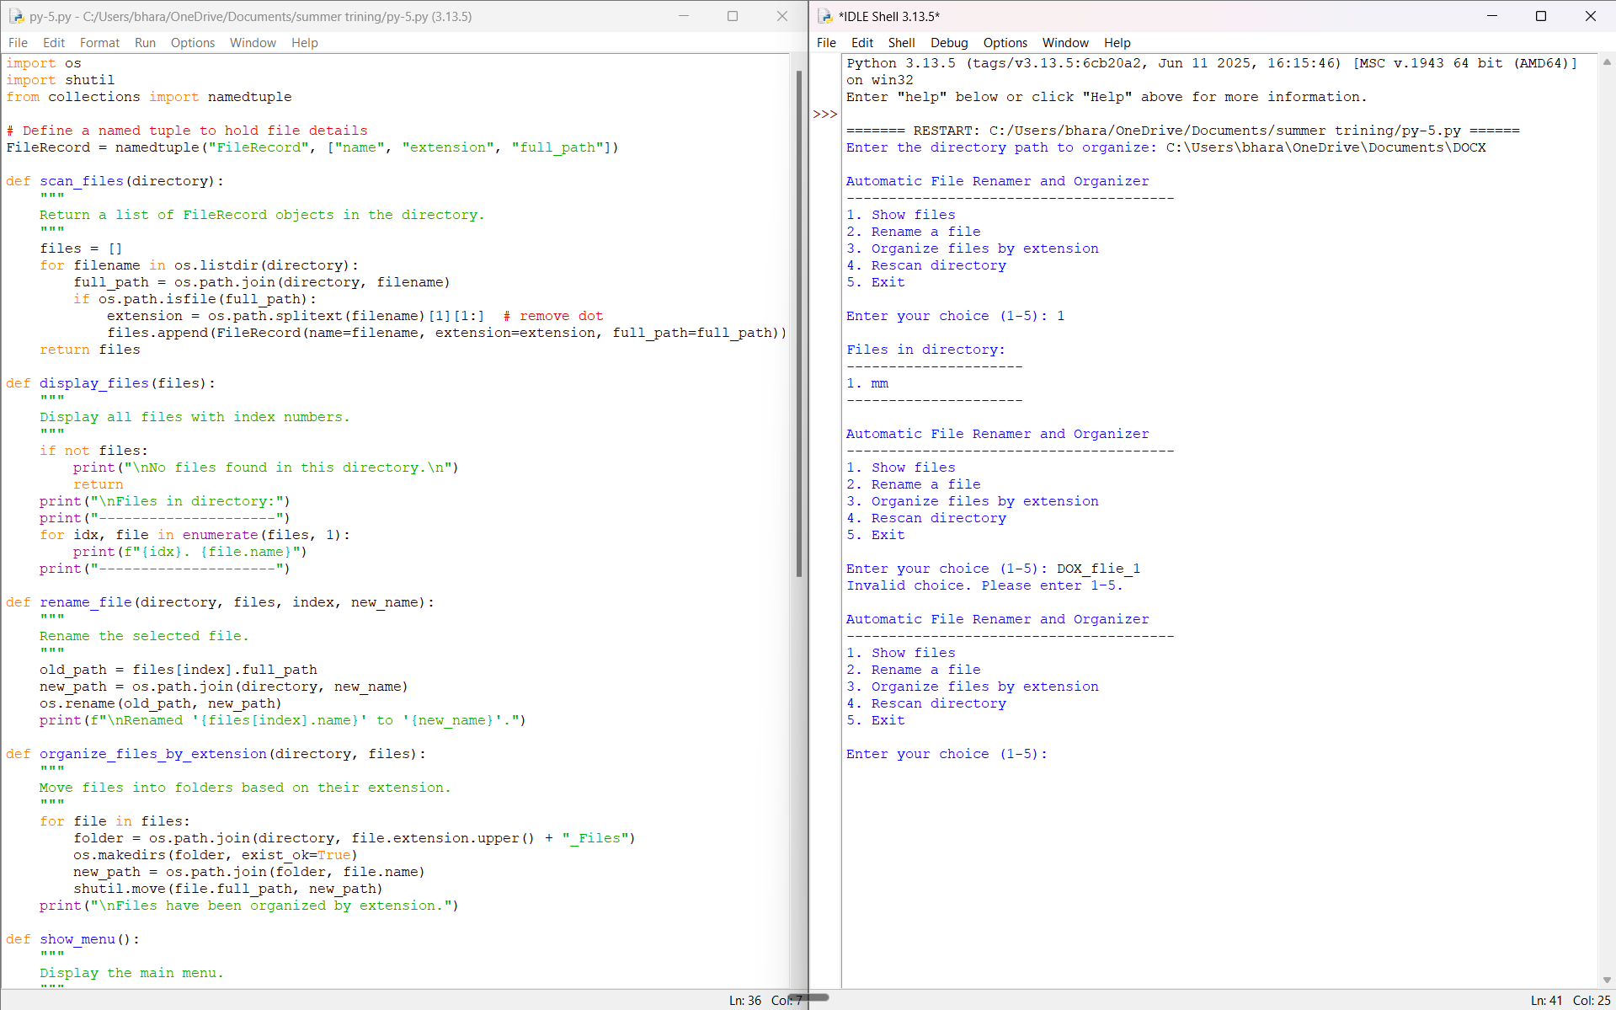
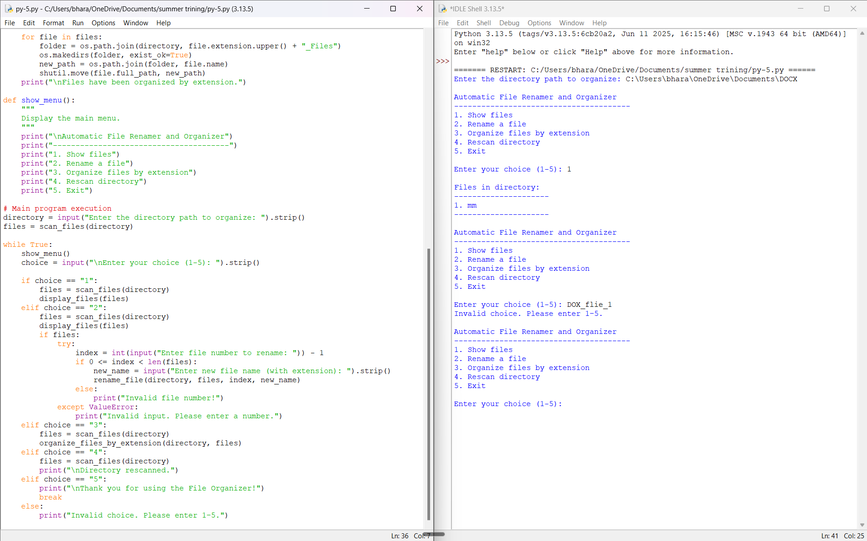

Conclusion
This project successfully demonstrates how Python can be used to automate file management tasks. The application provides a user-friendly menu-driven interface that enables users to list, rename, and organize files with minimal effort. By automating these operations, the project improves efficiency and consistency in maintaining digital files. Potential future enhancements could include adding recursive folder scanning, duplicate name handling, and a graphical user interface.

